A Retrieval-Augmented Generation (RAG) Architecture for Low-Resource Languages: A Case Study on Sinhala-Medium Secondary Business Education
S25021960 M.A.A.T. Perera

Abstract

This study proposes designing and testing a RAG model grounded on a verified Sinhala knowledge base based on a business studies course. To compare this proposed RAG model with an ungrounded model, we will utilize a series of metrics including faithfulness, hallucination rate, retrieval accuracy and response quality. Our objective is to demonstrate empirically that a curriculum-based RAG model can significantly decrease hallucinations in Sinhala. In addition, our study will provide a curated educational dataset for Sinhala and a reusable framework for low resource educational RAG systems.

I. Introduction

Because Language Models rely entirely on memorized parameters, they have no way of knowing if what they say is correct or not. This issue is known as "hallucination." One approach to address this issue is through Retrieval-Augmented Generation (RAG), which uses an external reference or source to ground the generated response [1].

However, the advantages of RAG have not been equally distributed among all languages. Although there are 17 million native speakers of Sinhala, it is still considered a Low Resource Language, thus underrepresented in training data.

Students studying for the General Certificate of Education Ordinary Level (GCE OL) examinations in Business Studies in Sinhala are at risk of encountering both unreliability and deception when seeking assistance from Large Language Models. Furthermore, because Low Resource Languages have limited coverage, models tend to fill those gaps with believable but untrue content [9]. Also, main stream tokenizers mis-tokenize the Sinhala script which causes the model's generated output to be poor [24] [26].

A. Rationale
Because Sri Lanka is on one side of a Digital Divide regarding education technology, Sri Lankan students cannot use tutoring tools that are successfully being used by students in other parts of the world. This project represents the first time that retrieval has been applied to Formal Sinhala or generation has been anchored into a Sri Lankan Curriculum.

B. Requested Supervisor:
A supervisor who has expertise in either Natural Language Processing, large language models or low-resource language research would be greatly helpful. Additionally, familiarity with retrieval augmented generation and its evaluation techniques would be beneficial.

II. LITERATURE REVIEW

Hallucinations of LLMs in Low Resource Languages
An essential barrier to having faith in LLMs when accurate responses matter is hallucination [8]. For example, Trivedi et al., found that there were models giving confident false answers due to the sparseness of the semantic coverage of these models [9]. The detection of such hallucinations does not become simpler either. The internal signals indicating hallucinations remain strong even when the model’s accuracy becomes poor [10]; additionally, there was little consistency on what was considered to be the best way to detect hallucinations across varying levels of resources [11].

B. RAG Architecture and Optimizations
Lewis et al., developed a hybrid architecture combining a neural retriever with a generator using an external knowledge base instead of relying solely upon parameters [1]. To date, several mappings of "best practices" have been created regarding configurations [2], however, the optimal values of some relatively small decisions made during training (e.g. chunk size, segmenting) can result in measurable differences in accuracy [3] [4] and designing architectures that include many components can increase accuracy at the expense of increased complexity [5]. Nearly all of the evidence supporting these findings came from experiments conducted using English; therefore, it remains unclear if similar configuration settings would apply to Sinhala.

C. Cross-Lingual Retrieval and Embedding Models
Recent studies (TyDi and MIRACL) demonstrated that transferring dense retrieval to unseen languages results in limited success [12] [13], and cross-lingual studies reported the same [14] [15]. However, some progress has occurred. Contrastive fine-tuning of BGE-M3 resulted in improvements in retrieval performance for under-resourced languages [16], and native benchmarks demonstrated how greatly machine translated test set data exaggerated previous results [18]. Perhaps most relevantly, DR-RAG successfully reduced retrieval misalignment in Urdu (which has morphological characteristics similar to those of Sinhala), by indexing question-answer pairs along side passages [23].

D. Sinhala NLP: Models, Corpora and Benchmarks
A common thread among studies related to Sinhala NLP is tokenization. Due to widespread use of mainstream tokenizers resulting in split scripts, both SinLlama and Sinhala encoder-only models had to develop their own methods to overcome inefficient sub-word segmentation

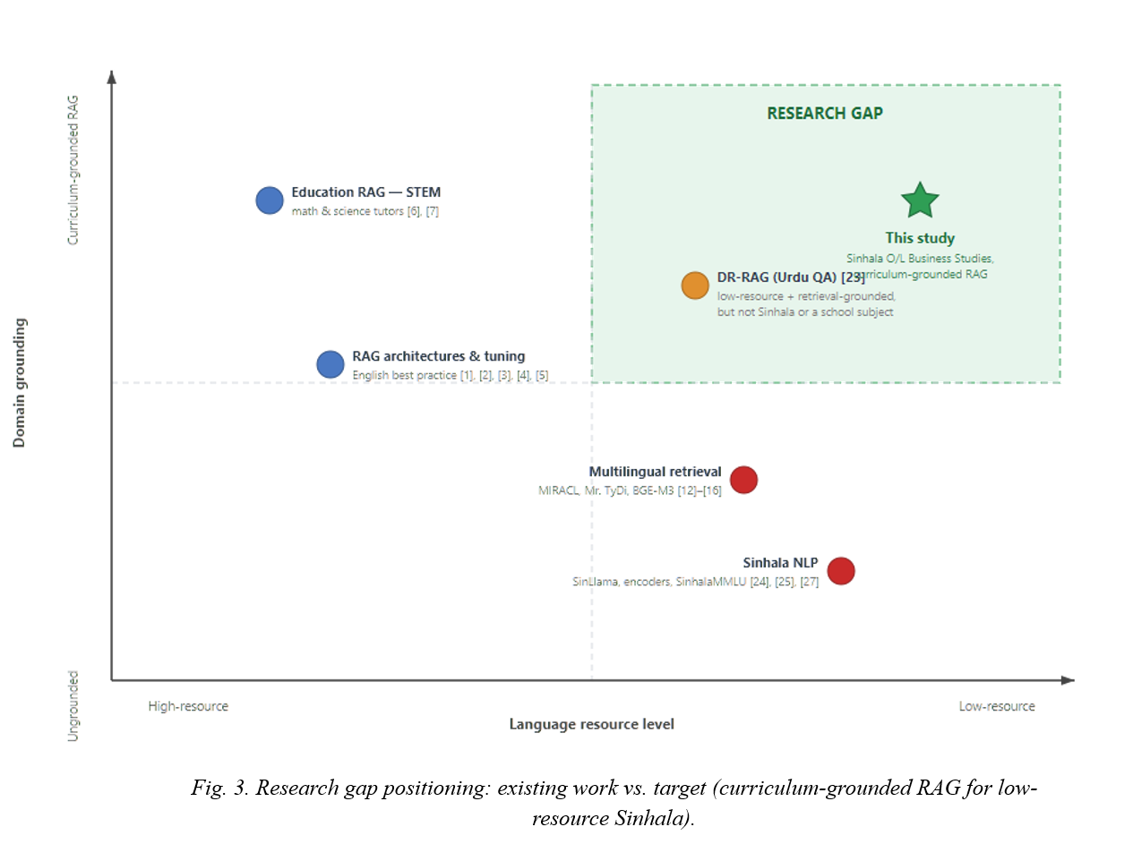
issues [24] [25]. Similarly, SinhalaMMLU confirmed that current models continue to face challenges in processing Sinhala language [27], whereas Jayakody and Dias indicated that both Claude and GPT-4o perform reasonably well when processing Sinhala language without requiring fine tuning [26]. Although these studies provide useful components, none employ retrieval grounding nor link to a specific school subject.
Fig. 1. Research gap positioning: existing work vs. target (curriculum-grounded RAG for low-resource Sinhala).

E. RAG Applications in Education
While Levonian et al. employed a retrieval based grounding method to create a vetted math tutoring system [6] and a subsequent framework employed retrieval coupled with code execution for science applications [7], both are restricted to high resource languages and STEM subjects.

III. RESEARCH GAPS

The Retrieval-Augmented Generator (RAG) decreases hallucinations, however the configuration of RAG was evaluated in English, and the only study that has examined

the effect of retrieval misalignment in a morphologically rich language with limited resources was conducted on Urdu and not on Sinhala. The literature provides generators, embeddings, and a benchmark, but none have been developed as part of a retrieval pipeline or based upon a school subject. Therefore, what has not yet been investigated is if a RAG architecture built around a domain of O/L Business Studies content within a Sinhala medium will be able to decrease hallucinations when compared to a baseline and which retrieval settings provide optimal results for the use of Sinhala.

IV. PURPOSE AND GOALS

A. Aim
Design and Evaluate the Effectiveness of a RAG Architecture Built Upon a Verified Sinhala Medium O/L Business Studies Knowledge Base That Decreases Hallucination and Increases Faithfulness Compared To A Baseline Large Language Model.

B. Objectives
1. Review literature on LLM hallucination, RAG optimization, and low-resource retrieval.
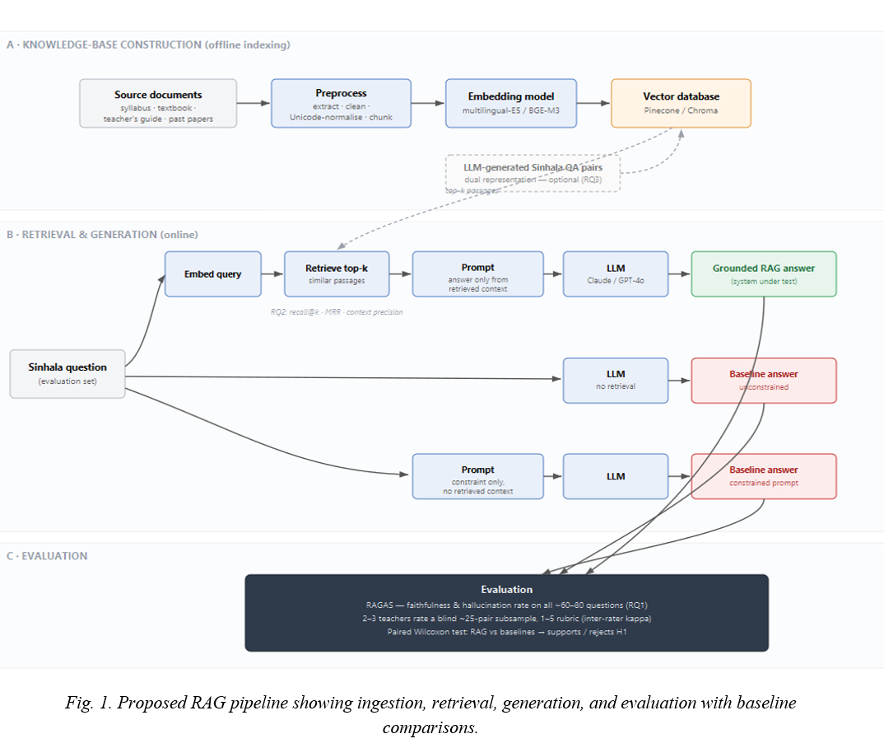
2. Curate a verified Sinhala-medium O/L Business Studies knowledge base.
Fig. 2. Proposed RAG pipeline showing ingestion, retrieval, generation, and evaluation with baseline comparisons.
3. Identify the best embedding model and chunking strategy for Sinhala educational text.
4. Implement a modular RAG pipeline (retrieve, prompt, generate).
5. Evaluate retrieval accuracy and answer faithfulness against a baseline LLM.
6. Derive design guidelines for localizing RAG to other low-resource domains.

V. RESEARCH QUESTIONS

RQ1: Will using a verified knowledge base of Sinhala O/L Business Studies (RAG) as a basis for grounding answers to business studies-related questions decrease the rate of hallucinations and increase faithfulness when compared against a baseline LLM?

RQ2: Using which embedding model(s) and/or combination of chunking strategies will provide the best possible results for formally educating students through the use of Sinhala language text?

RQ3: (Optional/Stretch): Can incorporating LLM generated Sinhala Q&A's into the indexing process (Dual Representation), enhance retrieval performance above that obtained from traditional single vector indexing methods?
Hypothesis (H1): That a RAG based on verified curriculum content for Sinhala education, provides significant improvement in terms of answer faithfulness, while decreasing the rate of hallucination, relative to a baseline LLM providing answers in formal Sinhala.

Proposed RAG Pipeline / System Design
The architecture is modular, so components can be swapped. At ingestion, passages are embedded and stored in a hosted vector database. At query time, a question is embedded, similar passages retrieved, and placed in a prompt instructing the model to answer only from context. To separate the effect of retrieval from the effect of the answer-only-from-context instruction, two baselines are used: (i) an unconstrained baseline, the same model answering freely, no retrieval; and (ii) a constrained-prompt baseline, the same constraint instruction but still no retrieval. Comparing RAG against both isolates the contribution of grounding itself. An optional adaptive variant indexes LLM-generated QA pairs, falling back to them when passage matching is weak.

VI. RESEARCH METHODOLOGY

A. Research Philosophy and Approach
This research has taken a positivistic, deductive approach: the assumption that grounding in Sinhala curriculum material will reduce hallucinations has been empirically tested through a controlled experiment involving comparative analysis of the performance of the rag system versus an ungrounded control group on equivalent Sinhala questions.

B. Development Methodology
Ingestion involves passing segments of document through embeddings and storing these in a hosted vector database. At query Time, a question is passed through embeddings, the most similar passages are retrieved, and a prompt directing the model to generate answers based only on context provided. To isolate the impact of retrieval vs. The impact of the answer only from context directive, two baselines will be utilized:
(i) an unrestricted baseline, the same model given free rein to respond without retrieval;
(ii) a constraint-prompt baseline, the same constrained directive to answer from context however also without retrieval. An adaptive version of the pipeline indexes LLM generated QA pairs for use when weak matches occur.

C. Evaluation Methodology
approximately 60–80 Sinhala questions comprise the evaluation set derived from recent past papers and the prescribed textbook — all with a confirmed reference answer. The evaluation set is paired because all questions are answered by both the rag system and the baselines; differences in score are thus assessed using the Wilcoxon signed-ranked test (or a paired t-test should distributional assumptions hold) — thereby supporting or rejecting h1.

automated questionnaire #1 faithfulness and hallucination rate measures are compared among the grounded system and the two baselines — calculated in Python using RAGAS.

human validation questionnaire #1. although the automated metrics depend upon an LLM evaluating Sinhala (the very environment cited by prior research as being one of weakness [9] [27]), their results are independently validated by domain experts. two to three O/L Business Studies teachers separately assess a blind sub-sample of approximately 25 answer pairs (system identity concealed, order randomized) on accuracy and faithfulness using a 1–5 rubric. Agreement among assessors is reported (kappa coefficient); human ratings are correlated with RAGAS scores; high levels of agreement support automated results while disagreement constitutes findings.

questionnaire #2. the most effective embedding models and chunking strategies are determined on recall @ k, mean reciprocal rank, and context precision to select retrieval configuration used in rq#1.

questionnaire #3 (optional). dual representation retrieval is compared to single vector retrieval on equivalent retrieval measures.

D. Project Management Methodology
The duration of the project is approximately four months beginning on April 1st, 2026, and ending on July 31st, 2026.

E. Gantt Chart

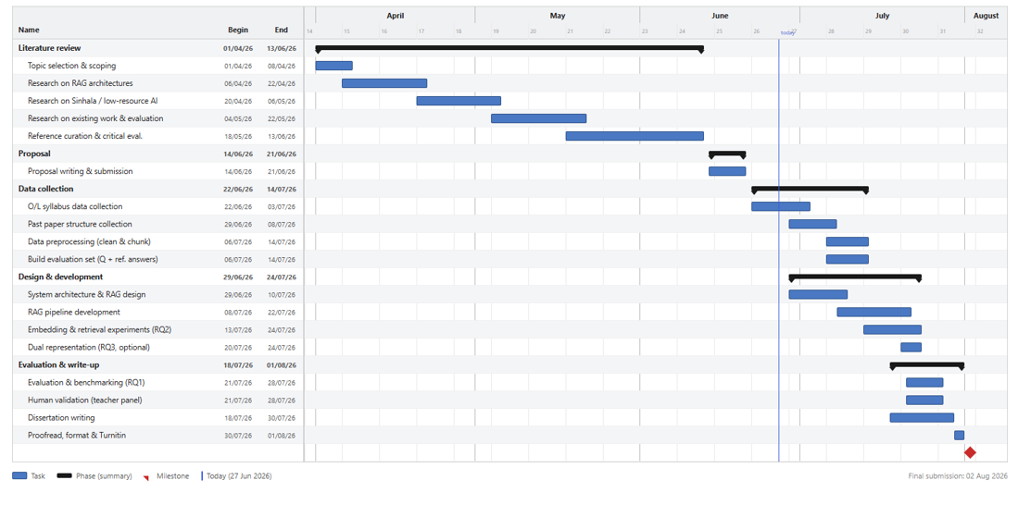
V. Resource Requirements
Fig. 3. Gantt Chart

A. Software Resources
A proprietary LLM (Claude or GPT-4o Gemini) is accessed via a paid API for Sinhala response generation. Embedding is performed using multilingual-E5 and BGE-M3 (open-source, via Hugging Face). The vector database is either Pinecone (hosted) or Chroma (local). LangChain constructs the pipeline and RAGAS performs evaluation, both open-source Python libraries.

B. Hardware Resources
No specialised hardware is required. All model inference and embedding is accessed
via hosted APIs; a standard laptop with internet connectivity is sufficient throughout the project.

E. Data Requirements
The NIE O/L Business Studies syllabus, prescribed textbook, teacher's guide, and recent past papers serve as the knowledge base. All documents are publicly available, have already been collected in PDF format, and processed for ingestion via extraction, cleaning, Unicode normalization, and segmentation. An additional set of 60–80 curriculum-aligned evaluation questions with confirmed reference answers will be compiled by the researcher.

F. Skill Requirements
The project requires proficiency in Python, familiarity with LangChain and vector database APIs, and working knowledge of NLP evaluation frameworks (RAGAS).

E. Risks and Mitigations
Risk | Mitigation
API rate limits or cost overruns | Evaluation set is intentionally small (60–80 questions); usage is monitored per run
Proprietary model unavailability | Claude and GPT-4o are interchangeable within the pipeline
LLM-based evaluation bias for Sinhala | Human validation by domain expert teachers provides an independent check
Limited Sinhala tokenization quality | BGE-M3 and multilingual-E5 are benchmarked against each other to select the better performer

VI. ETHICS OF THE STUDY

This study employs only published curricular documents. No personal identifiable information is utilized; all materials have been collected by the researcher for academic use and properly cited. In addition, there is no transfer of copyrighted material to third parties. Teachers who volunteer to provide their expertise through informed consent review anonymized versions of the system's output generated from the study aid.

VII. LIMITATION & SCOPE OF THIS STUDY

It is limited to GCE Ordinary Level Business Studies (Sinhala language version) in one country (Sri Lanka); it severely limits its generalizability. There are also limitations related to cost and rates associated with hosted APIs that limit reproducibility. This study is based solely upon retrieval and prompt-based improvements and no machine learning models were developed. As such, the size of the evaluation set is relatively small (approximately 60-80 questions), which limits the statistical power of this study. Automated metrics for evaluating these prompts utilize an LLM to judge Sinhala and thus the automated metrics are validated using a small panel of teachers. Additionally, because the automated metrics do not completely assess pedagogically relevant aspects, it is possible that some metrics may be biased.

VIII. ANTICIPATED RESULTS FROM THIS STUDY

This study will develop: A modular RAG architecture specifically for Business Studies in Sinhala; An evaluation set of curriculum questions and corresponding reference answers; Empirical evidence demonstrating whether grounding can reduce hallucinations within the architecture by optimizing embedding and chunking parameters; And a conceptual framework for developing similar architectures in other subjects and low resource languages.

REFERENCES

[1] P. Lewis, E. Perez, A. Piktus, F. Petroni, V. Karpukhin, N. Goyal, H. Küttler, M. Lewis, W. Yih, T. Rocktäschel, S. Riedel, and D. Kiela, "Retrieval-augmented generation for knowledge-intensive NLP tasks," in Advances in Neural Information Processing Systems (NeurIPS), vol. 33, 2020, pp. 9459–9474.

[2] X. Wang, Z. Wang, X. Gao, F. Zhang, Y. Wu, Z. Xu, T. Shi, Z. Wang, S. Li, Q. Qian, R. Yin, C. Lv, X. Zheng, and X. Huang, "Searching for best practices in retrieval-augmented generation," in Proc. 2024 Conf. on Empirical Methods in Natural Language Processing (EMNLP), 2024, pp. 17716–17736.

[3] A. Ammar, A. Koubaa, O. Nacar, and W. Boulila, "Optimizing retrieval-augmented generation: Analysis of hyperparameter impact on performance and efficiency," arXiv preprint arXiv:2505.08445, 2025.

[4] Z. Wang, C. Gao, C. Xiao, Y. Huang, S. Si, K. Luo, Y. Bai, W. Li, T. Duan, C. Lv, G. Lu, G. Chen, F. Qi, and M. Sun, "Document segmentation matters for retrieval-augmented generation," in Findings of the Association for Computational Linguistics: ACL 2025, 2025.

[5] D. O. Opoku, M. Sheng, and Y. Zhang, "DO-RAG: A domain-specific QA framework using knowledge graph-enhanced retrieval-augmented generation," arXiv preprint arXiv:2505.17058, 2025.

[6] Z. Levonian, C. Li, W. Zhu, A. Gade, O. Henkel, M.-E. Postle, and W. Xing, "Retrieval-augmented generation to improve math question-answering: Trade-offs between groundedness and human preference," in Proc. NeurIPS'23 Workshop on Generative AI for Education (GAIED), 2023.

[7] J. Lu and J. Li, "A novel framework for educational Q&A: Leveraging RAG and code interpreters for knowledge retrieval and logical computation," PLOS ONE, 2025.

[8] A. Alansari and H. Luqman, "Large language models hallucination: A comprehensive survey," Computer Science Review, vol. 61, art. 100970, 2026.

[9] K. Trivedi, M. Shaikh, S. Sharma, et al., "'So, how much do LLMs hallucinate on low-resource languages?' A quantitative and qualitative analysis," in Proc. Workshop on Language Models for Low-Resource Languages (LoResLM), 2026.

[10] D. Datta, M. K. Chilukuri, Y. Kumar, S. Ghosh, and M. B. Zafar, "Do LLM hallucination detectors suffer from low-resource effect?," in Proc. 18th Conf. of the European Chapter of the Association for Computational Linguistics (EACL), 2026.

[11] K. Benkirane, L. Gongas, S. Pelles, N. Fuchs, J. Darmon, P. Stenetorp, D. I. Adelani, and E. Sánchez, "Machine translation hallucination detection for low and high resource languages using large language models," in Findings of the Association for Computational Linguistics: EMNLP 2024, 2024, pp. 9647–9665.

[12] X. Zhang, N. Thakur, O. Ogundepo, E. Kamalloo, D. Alfonso-Hermelo, X. Li, Q. Liu, M. Rezagholizadeh, and J. Lin, "MIRACL: A multilingual retrieval dataset covering 18 diverse languages," Trans. Assoc. Comput. Linguistics (TACL), vol. 11, 2023.

[13] X. Zhang, X. Ma, P. Shi, and J. Lin, "Mr. TyDi: A multi-lingual benchmark for dense retrieval," in Proc. 1st Workshop on Multilingual Representation Learning (MRL), 2021.

[14] R. Litschko, I. Vulić, S. P. Ponzetto, and G. Glavaš, "On cross-lingual retrieval with multilingual text encoders," Information Retrieval Journal, vol. 25, no. 2, 2022.

[15] L. Zuo, P. Hong, O. Kraus, B. Plank, and R. Litschko, "Evaluating large language models for cross-lingual retrieval," in Findings of the Association for Computational Linguistics: EMNLP 2025, 2025, pp. 11415–11429.

[16] A. Omotoso, H. Shopeju, A. Joshua, and S. Oni, "Improving BGE-M3 multilingual dense embeddings for Nigerian low resource languages," in Proc. Widening NLP Workshop (WiNLP), 2025.

[17] Z. Zhang, Z. Liao, H. Yu, P. Di, and R. Wang, "ML-Embed: Inclusive and efficient embeddings for a multilingual world," arXiv preprint arXiv:2605.15081, 2026.

[18] W. Ponwitayarat, R. Ng, J. R. Montalan, T. Aung, et al., "SEA-BED: Southeast Asia embedding benchmark," Association for Computational Linguistics, 2025.

[19] H. Luo, X. Luo, W. Zhao, Q. Peng, K. Chen, Y. Liu, and C. Du, "Domain-specific retrieval-augmented generation with adaptive embedding and knowledge distillation-based re-ranking," Processes, vol. 14, no. 1, 2026.

[20] P. Guo, Y. Ren, Y. Hu, Y. Li, J. Zhang, X. Zhang, and H. Huang, "Teaching large language models to translate on low-resource languages with textbook prompting," in Proc. 2024 Joint Int. Conf. on Computational Linguistics, Language Resources and Evaluation (LREC-COLING), 2024.

[21] H. Li, H. Zhang, M. Li, Y. Wang, L. Wen, Y. Zhang, and B. Huang, "Toward robust multilingual adaptation of LLMs for low-resource languages," arXiv preprint arXiv:2510.14466, 2025.

[22] T. Liu, J. Qi, M. Sachan, R. Cotterell, R. Fernández, and A. Bisazza, "Post-training language models for crosslingual consistency," arXiv preprint arXiv:2603.04678, 2026.

[23] S. Ahmad, M. Hammad, M. Zeeshan, F. Ullah, and A. Karim, "DR-RAG: Addressing retrieval misalignment in low-resource Urdu question answering," in Proc. 2nd Workshop on Challenges in Processing South Asian Languages (CHiPSAL) @ LREC, 2026, pp. 49–58.

[24] H. W. K. Aravinda, R. Sirajudeen, S. Karunathilake, N. de Silva, R. Kaur, A. S. Bhankhar, and S. Ranathunga, "SinLlama — A large language model for Sinhala," arXiv preprint arXiv:2508.09115, 2025.

[25] T. Ranasinghe, H. Hettiarachchi, N. Pathirana, D. Premasiri, L. Uyangodage, I. Anuradha, A. Plum, P. Rayson, and R. Mitkov, "Sinhala encoder-only language models and evaluation," in Proc. 63rd Annual Meeting of the Association for Computational Linguistics (ACL), 2025.

[26] R. Jayakody and G. Dias, "Performance of recent large language models for a low-resourced language," in Proc. 2024 Int. Conf. on Asian Language Processing (IALP), 2024, pp. 162–167.

[27] A. Pramodya, N. Nelki, H. Shalinda, C. Liyanage, Y. Sakai, R. Pushpananda, R. Weerasinghe, H. Kamigaito, and T. Watanabe, "SinhalaMMLU: A comprehensive benchmark for evaluating multitask language understanding in Sinhala," in Proc. 2025 Conf. on Empirical Methods in Natural Language Processing (EMNLP), 2025.

